Auto-saving in EwE
A central auto-save structure was introduced to EwE version 6.3, which determines how EwE components automatically write computed results to disk.
After the release of EwE 6.3 the auto-save structure has been extended to include plug-ins.

Configuration
The auto-save structure can be accessed from the Options menu (Menu > Tools > Options) or directory via the new ‘Auto-save settings’ button on the Model bar (Figure 1).
Note that in this figure, in addition the usual suspects, the Value Chain plug-in is listed as offering auto-save capabilities. The Value Chain plug-in is currently set to automatically save results.
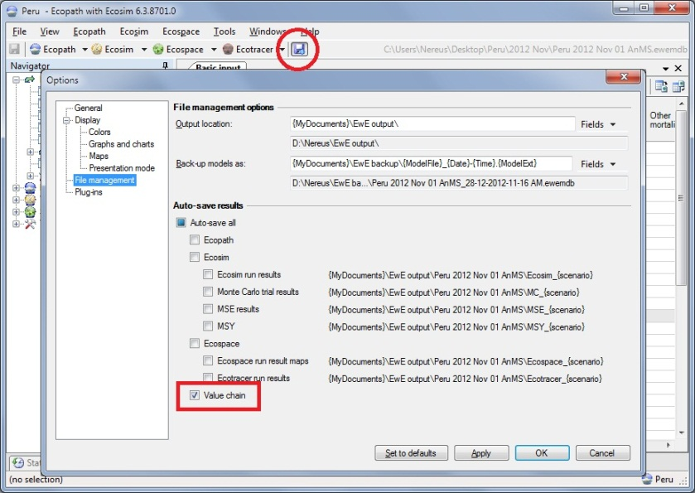
Figure 1 - Accessing auto-save settings

Feedback to the user
Figure 1 shows a few other noteworthy features:
- The auto-save checkboxes are organised in a hierarchal manner. The ‘auto-save all’ checkbox is shaded to indicate that some of its child checkboxes are checked (in this case only the Value Chain option). The user can toggle the value of any check box, which will cascade through the hierarchy for making quick selections;
- If applicable, auto-save components will show the path to where data will be saved based on the loaded model and scenario(s);
- The ‘Auto-save settings’ button in the Model bar will be pressed if any component is set to auto-save to provide the user with a quick overview;
- Any auto-save action will be listed in the status panel (See also Figure 3).

Implementation in the Value Chain
The Value Chain plug-in auto-save integration can also be configured directly from the Value Chain parameters user interface (Figure 2).
Figure 2 - Auto-save options in the Value Chain

Note that toggling the ‘Automatically save results to CSV file’ option in the Value Chain parameters form will cause the ‘Auto-save settings’ button in the Model toolbar to immediately alter its state.
When the Value Chain is ran and its auto-save setting is enabled a CSV file is written to disk. The status panel will inform the user where this file is located (Figure 3).
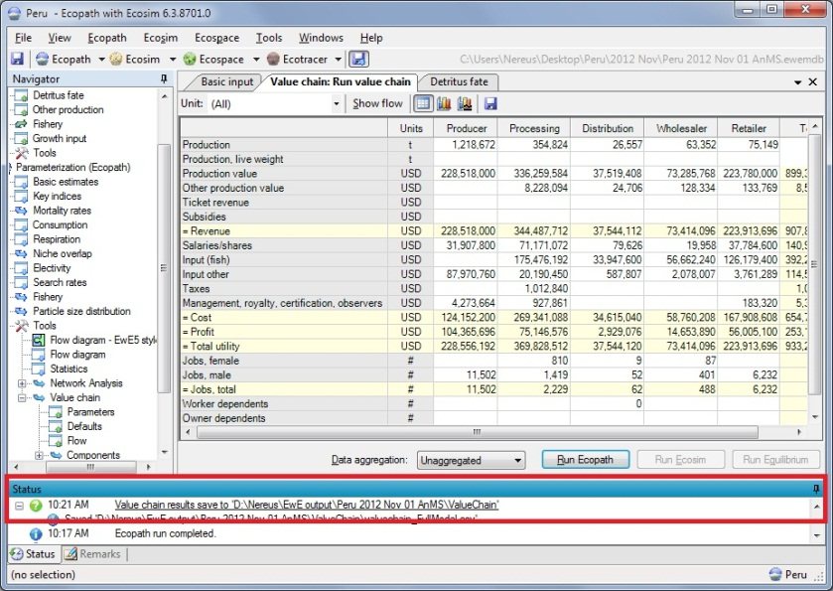
Figure 3 – Save notifications in the status panel

Note that the status panel entry is underlined indicating a hyperlink. Clicking a hyperlinked entry in the status panel will tell the operating system to navigate to the link. In this case, Windows Explorer will launch to the directory that contains the file written by the Value Chain.

Manual saving Value Chain results
The user can also manually save Value Chain results without using the auto-save option. For this purpose, a save button has been added to the Value Chain results form (Figure 4).
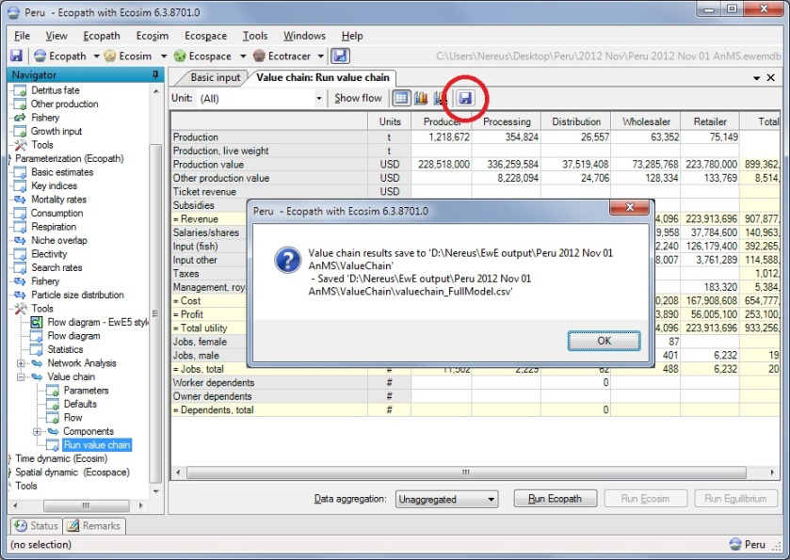
Figure 4 – Manually save Value Chain results

When the manual save option is used a message box pops up confirming save results (Figure 4). Note that the save event will be logged in the status panel as shown in Figure 3, which can be clicked to see the actual file, etc.

